 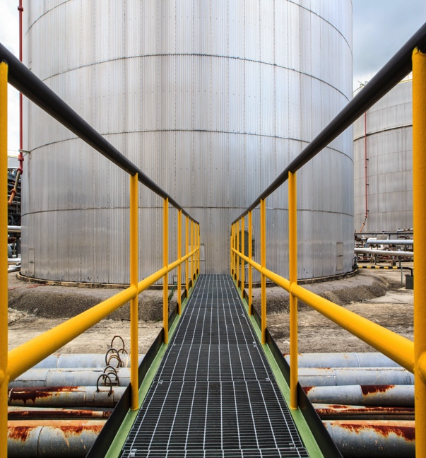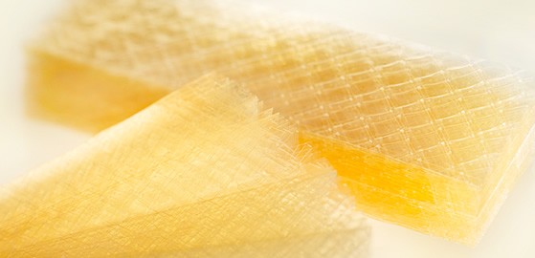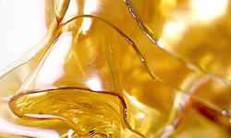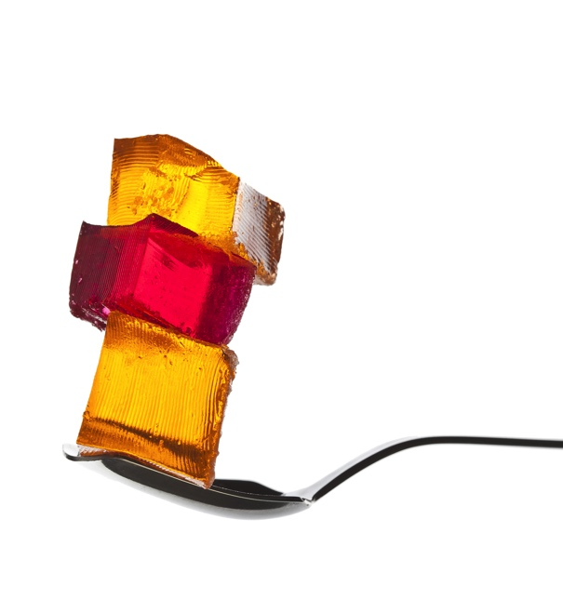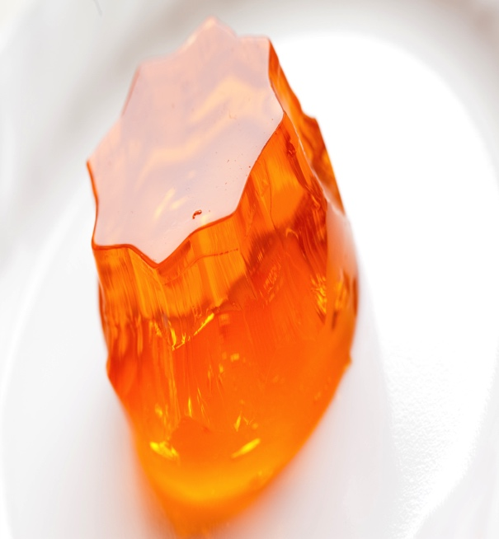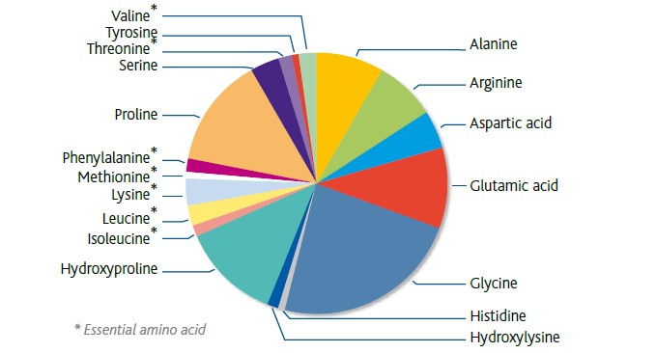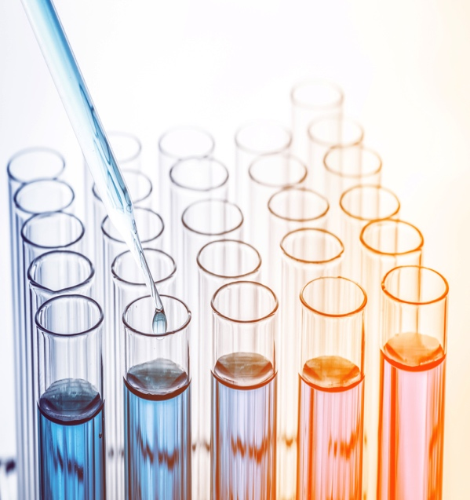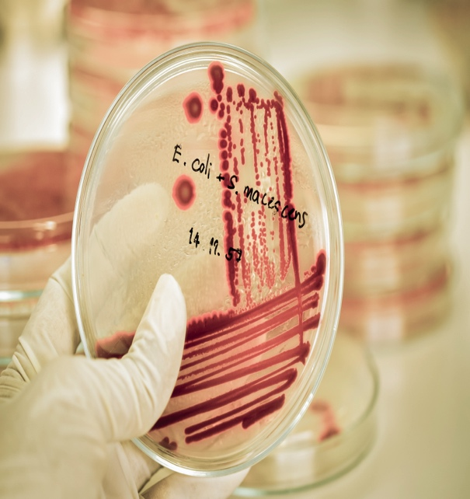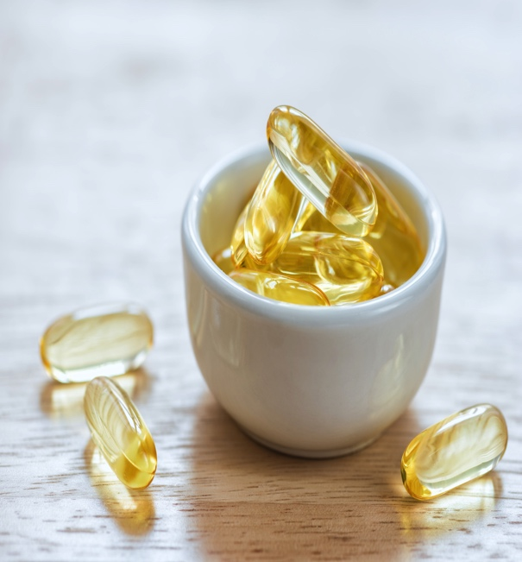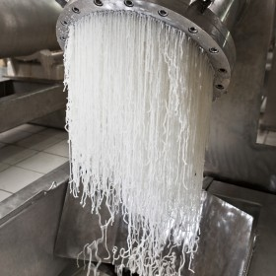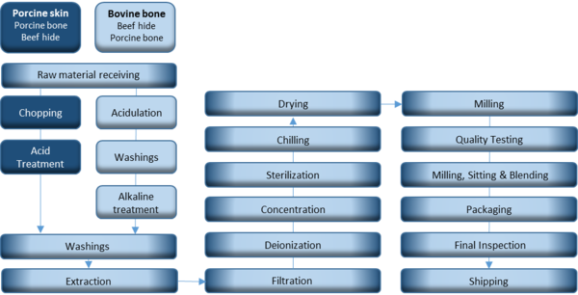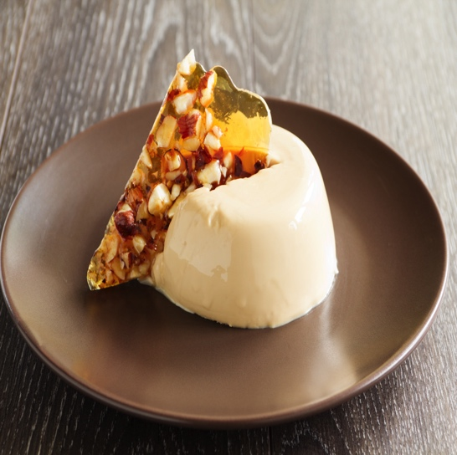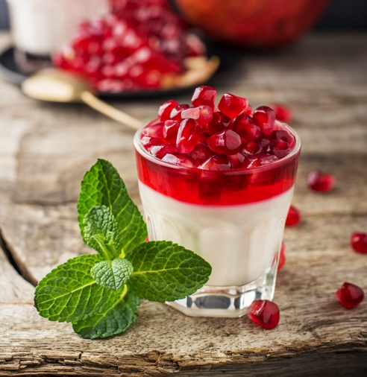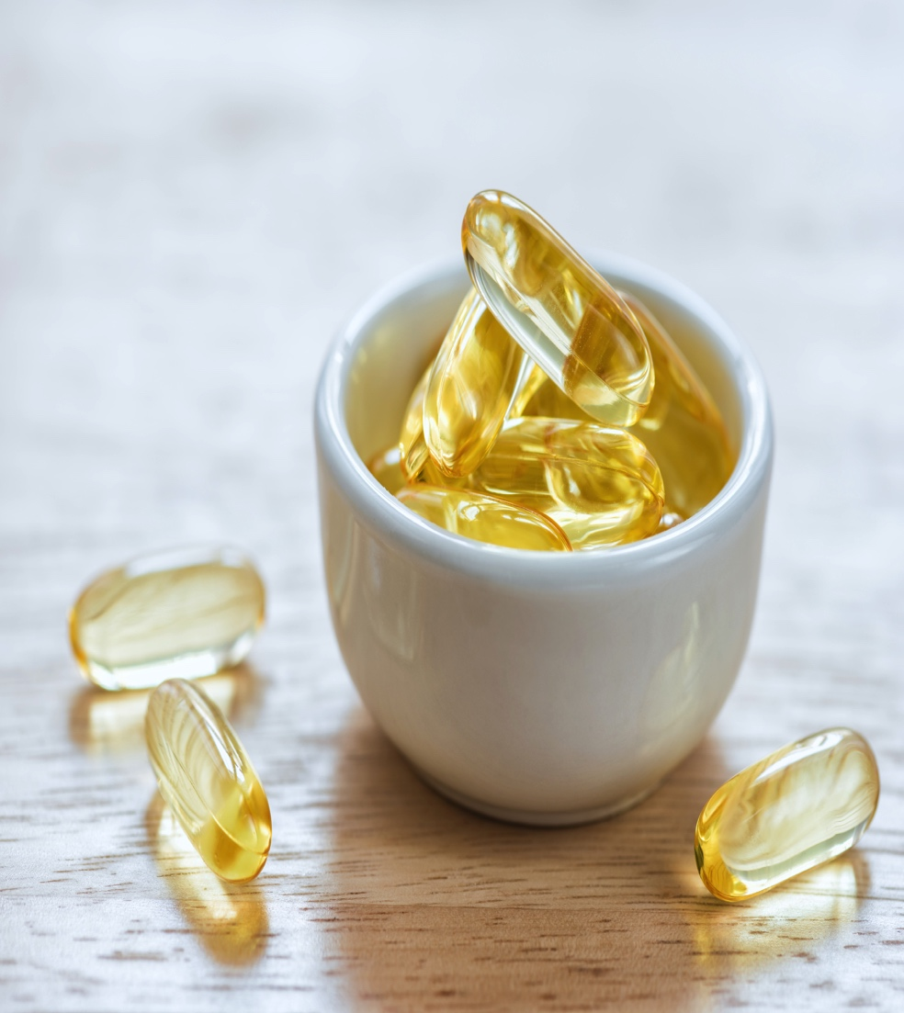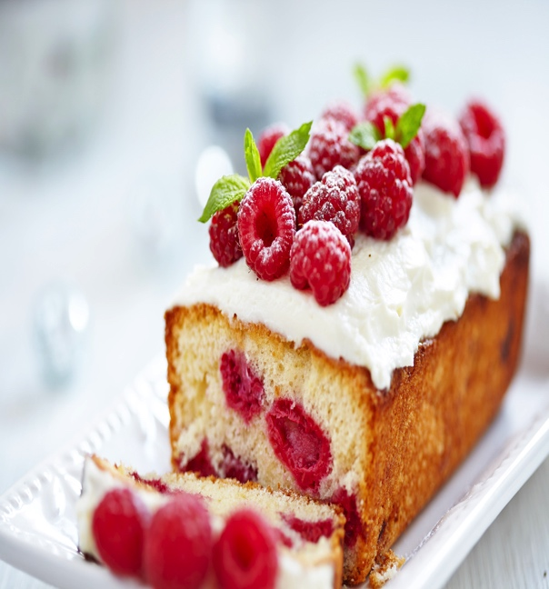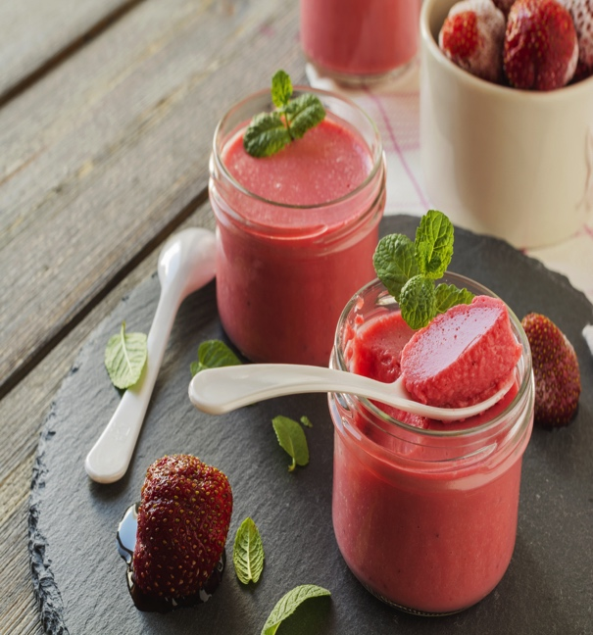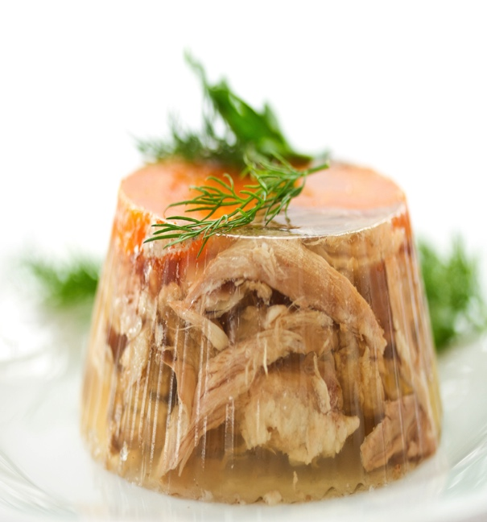

ABALONE GELATIN

Transforming Life

The specialist in Gelatin manufacturing and products, we at Abalone congratulate you to have reached your destination. Your search has ended and we will henceforth embark upon a journey together! A full-proof solution for your every answer, Abalone is here with top-class superior services and solutions. Whether you are a consumer or a supplier, Abalone promises you the best of it's services. World-class services, superiority of products, experienced and skilled pool of scientists and researchers, excellent local team for individual guidance: Abalone guarantees everything.

World is changing and the challenges are growing with it. Higher expectations, comfortable and luxurious lifestyles, unique and innovative ideas: we fulfill all your demands and expectations at Abalone. Through the creation of natural gelatin and the innumerable innovative products from it, we aim to transform the lives of people in a positive way. And this can't be achieved alone, we want you: our customers to be with us. Together we'll transform. We don't want you to believe us blindly. Discover and witness it for yourself how we transform your lives.

**What’s Good for India is Good for Us**

# ABALONE

# TRANSFORMING LIVES SINCE YEARS

**An Innovative Ingredient With Added Value**

Gelatin is an all-rounder that is used in the most diverse sectors of industry and products, and which develops its stabilising effect quite naturally. Gelatin is a natural and pure protein - free from fat, carbohydrates, cholesterol, allergens and additives. It's a foodstuff without an E-number. Gelatin is obtained through partial hydrolysis of collagen contained in animal skins and bones. It is a natural protein food typically consisting of 85% protein, 13% water and 2% minerals with a calorific value of 370 kcal per 100g.

Gelatin is uniquely versatile in terms of functional properties. Not only can the product be used to form gels, it's also able to form films, emulsions and foams. Moreover, it's an excellent binder, adhesive and stabilizer. Therefore, gelatin is used in numerous and diverse applications, varying from the preparation of food and pharmaceutical products to industrial use.

**Leaf Gelatin**

Special form of edible Gelatin. It is especially easy to dose and is therefore mainly used in the household.

**Instant Gelatin**

Instant Gelatins or powder Gelatins are soluble in cold water. They were specially developed to control the temperature of Gelatin, thus stopping it melting when heated for example to stabilise gateaux and desserts.

**Hydrolysed Gelatin**

Hydrolysed collagens are non-gelling Gelatins and are also soluble in cold water. This form of Gelatin includes drinking Gelatins, which are available inhealth food stores.

# GELATIN – A UNIQUE HYDROCOLLOID

Gelatin is a pure protein obtained from raw materials containing collagen. It contains a total of 18 amino acids, including eight essential amino acids in varying concentrations. They link up to form polypeptide chains, with each chain containing as many as 1,000 amino acids. The entire gelatin structure is a rod-shaped molecule comprising a primary, secondary and tertiary structure.

The amino acid glycine is present in the most concentrated form with 20.6 g per 100 g gelatin, followed by proline with 11.7 g. Both of these amino acids are important components for connective tissue, lending it firmness and elasticity. The third important essential amino acid present in Gelatin is lysine (3.4 g per 100 g gel- atine). Lysine plays a major role in maintaining and forming new tissue and in cell and bone growth.

**A High-Quality Protein For Humans**

# GELATIN – A HIGH QUALITY PROTEIN

**Viscosity**

Viscosity is an important factor regarding the rheological behavior of a Gelatin solution. Once dissolved in water above its setting temperature, Gelatin will yield solutions typically ranging from 1.5 to 7.5 mPa.s. Viscosity is measured by a standardized method and indicates the flow time of 100 ml of a 6.67% Gelatin solution at 60°C (140°F) through a standard pipette.

**Solubility**

Solubilization of Gelatin is easy and concentrations of 40 to 45% are attainable. Typically, Gelatin needs to swell before it solubilizes in hot water, but it can also be dispersed directly in hot water under stirring

**Residue on ignition (ash)**

Percentage of residue after ashing at 550°C (1022°F) during 17 hours.

**Isoelectric point**

The isoelectric point is defined at the pH at which positive charges (from NH2 radical) equal negative charges (from COOH radical), and there is no movement in an electric field.

**Bloom (gel strength)**

A main characteristic used to describe Gelatin is the Bloom. Bloom is linked to the mechanical elasticity of the Gelatin gel. It is based on the re-arrangement of individual Gelatin chains into an ordered network. Bloom testing uses a standardized measurement. The Bloom indicates the force required to depress a prescribed area of the surface of a 6.67% Gelatin gel at 10°C (50°F) to a distance of 4 mm.

**Melting point & Setting point**

The melting point corresponds to the temperature at which Gelatin melts into solution.

The setting point corresponds to the temperature at which Gelatin forms a gel.

**Clarity**

Clarity of the Gelatin solution/gel is critical in a wide range of applications. It also indicates the efficiency of the filtration stage during the processing.

**Color**

Color depends on the raw materials, treatment and nature of the extracted Gelatins. Color is evaluated by visual observation and comparison with a range of control color scale.

# PROPERTIES & CHARACTERSTICS OF GELATIN

Unique Ingredient Unique Properties

Gelatin is a multi-talented ingredient. Its gelling, foaming, emulsifying and binding functionalities are complemented by numerous characteristics that make it irreplaceable in the pharmaceutical industry.

What really makes Gelatin unique in terms of functionalities is its thermo-reversible gelling power: a Gelatin-based formulation gels when cooled and liquefies when subsequently heated. This transformation occurs rapidly and can be repeated without significant changes in characteristics. There is no other ingredient in the world which combines as many functionalities as gelatin in just one product. In many applications several of the Gelatin properties are needed for the final product. Instead of Gelatin several other ingredients would be needed in combination to come close to the holistic Gelatin properties, but without equalling them.

In addition to all its functionalities, gelatin offers many other benefits. It brings many advantages such as thermo-reversibility, stability improvement, ease of use, ingredient compatibility, as well as human acceptance and compliance some of today’s major consumer trends.

**Gelatin’s Key functionalities:**

* Gelling
* Binding
* Foaming
* Thickening
* Emulsifying
* Film forming
* Fining
* Stabilizing
* Adhesion

# GELATIN – A MULTITALENTED INGREDIENT

A Hidden Innovation Driver

Gelatin is obtained through partial hydrolysis of the collagen contained in the raw material. The goal is to render the naturally insoluble collagen into gelatin, soluble in warm water. To reach this objective a complex, multi-stage process, interspersed with numerous chemical, physical and bacteriological quality controls has to be performed.

Two possible production processes can be used, the acid process or the alkaline process depending on the raw material used and the characteristics required for the end product. Whatever the process used, Gelatin production process follows six very specific steps: raw material pre-treatment, Gelatin extraction, Gelatin purification, semi-finished product recovery, blending of commercial lots and final release. All these production steps are always strictly and carefully controlled to meet specifications.

# PRODUCTION PROCESS – JOURNEY FROM RAW MATERIAL TO GELATIN

A Complex, Multi Stage Process

GELATIN APPLICATIONS

FOOD

**Confectionary**

Edible gelatin is indispensable for gummy bears, wine gums, jelly babies, chewy toffees, fruit chews, marshmallows, marshmallow wafers, chocolate marshmallows and many other [treats](http://www.gelatine.org/en/recipes/recipes/desserts.html). It gives them elasticity, the right degree of chewiness and a long shelf life. For light-as-air sweets, gelatin allows the foam to form and stabilizes it for the transport and storage of the products.

**Dairy products**

Dairy products are very popular. Gelatin plays an extremely important role in their preparation and in the development of even more new varieties. The right dose and the right type of gelatin ensure creamy-light yoghurts or more solid dairy products, such as curd cheese and kefir or event ice creams.

Whether firm or loose and light, gelatin gives creams and mousse desserts the desired consistency and that pleasant mouth feel.

**Meat, fish and sausages**

Gelatin is widely used in the meat industry for decorations, for the covering of cooked ham, cooked meats in general and in sausages for a more appetizing look. Apart from the aesthetic function, the gel of gelatin is an antioxidant agent and prevents the drying of the meat.

Gelatin can also be used inside meat to help the filling and the cutting.

In canned meat, gelatin help to absorb the liquids released during the sterilization in the steam sterilizer.

PHARMA

**Micro - Encapsulation**

Micro-encapsulation allows to change the solubility and the aspect of a substance (oil from liquid to powder), or to cover unpleasant odour or taste of the substance.

Micro-encapsulation can also protect the substance from oxidation or humidity.

The substance which has to be micro-encapsulated is finely dispersed in a gelatin solution and then transformed in a powder thanks to a further particular process of drying.

**Tablets**

For this application the adhesive properties of gelatin are exploited to give structure to the tablet.

Gelatin is submitted to wet granulation before the compression. The bloom value of the gelatin employed is essential for the dissolution of the tablet.

High bloom value for longer times, low bloom value for more rapid times of dissolution.

Hydrolysed gelatin is used for direct compression.

**Hard & Soft Capsules**

As the major [component](http://www.gelatine.org/en/applications/application-specials/health-care/gelatine-versatile-aids-in-medicine-and-the-pharmaceutical-industry.html) of hard and soft capsules, gelatin protects the sensitive drugs and other active substances against harmful influences, such as light or oxygen. Also it allows the application of active ingredients which cannot be administered orally or by injection. Soft capsules are mainly used for liquid fillings while hard capsules are mainly used for powder form fillings. Gelatin helps to keep the active pharmaceutical agents together reliably and for a long time.

TECHNIAL

**Photographic Industry**

Gelatin’s properties are needed to produce photographic materials such as amateur films, color paper, graphic films and X-ray films, in industrial volumes.

Gelatin is also indispensable for digital photography. The ink-jet printer paper coated with gelatin guarantees brilliant colors and clear shapes. This results in prints of the highest quality.

**Match Head**

Gelatin is used almost universally as the binder for the complex mixture of chemicals used to form the head of a match. The surface activity properties of gelatin are important since the foam characteristics of the match head influence the performance of the match on ignition.

**Restoration**

Whether it’s historical buildings or precious old papers and documents, Gelatin – is required to preserve and restore them. The naturally elastic binding properties of gelatin make it the ingredient of choice for many professional restorers when treating valuable or artistic work. For fine trowel work, warm gelatin is applied to the surface of the render with a fine brush. Combined with various sanding sessions, sculptural work can be returned to its previous perfection.



ABALONE

Transforming Life

Registered Office: 1596/302, 3rd Floor, New Building, Diwan Hall Gali, Bhagirath Palace, Chandni Chowk, Delhi – 110 006, India.

Tel: 011 23867204 Fax: 011 23867204 www.abaloneimpex.com

|  |
| --- |
|  |